<TEAM LOGO/NAME>

<YEAR> Security Assessment Report Prepared For
<REPLACE WITH CLIENT LOGO - CHANGE COLORS TOO>

Report Issued: <TEST DATE>

Confidentiality Notice
This report contains sensitive, privileged, and confidential information. Precautions should be taken to protect the confidentiality of the information in this document. Publication of this report may cause reputational damage to <CLIENT NAME> or facilitate attacks against <CLIENT NAME>. <TEAM NAME> shall not be held liable for special, incidental, collateral or consequential damages arising out of the use of this information.

Disclaimer
Note that this assessment may not disclose all vulnerabilities that are present on the systems within the scope of the engagement. This report is a summary of the findings from a “point-in-time” assessment made on <CLIENT NAME>’s environment. Any changes made to the environment during the period of testing may affect the results of the assessment.

TABLE OF CONTENTS
EXECUTIVE SUMMARY 3
<Optional - Big Issue> Recommendation 3
HIGH LEVEL ASSESSMENT OVERVIEW 4
Observed Security Strengths 4
Areas for Improvement 4
Short Term Recommendations 4
Long Term Recommendations 4
SCOPE 6
Networks 6
Other 6
Provided Credentials 6
TESTING METHODOLOGY 7
CLASSIFICATION DEFINITIONS 8
Risk Classifications 8
Exploitation Likelihood Classifications 8
Business Impact Classifications 9
Remediation Difficulty Classifications 9
ASSESSMENT FINDINGS 10
APPENDIX A - TOOLS USED 13
APPENDIX B - ENGAGEMENT INFORMATION 14
Client Information 14
Version Information 14
Contact Information 14

EXECUTIVE SUMMARY
<TEAM NAME> performed a security assessment of the internal corporate network of <CLIENT NAME> on <TEST DATE>. <TEAM NAME>’s penetration test simulated an attack from an external threat actor attempting to gain access to systems within the <CLIENT NAME> corporate network. The purpose of this assessment was to discover and identify vulnerabilities in <CLIENT NAME>’s infrastructure and suggest methods to remediate the vulnerabilities. <TEAM NAME> identified a total of <VULN TOTAL NUM> vulnerabilities within the scope of the engagement which are broken down by severity in the table below.

CRITICAL | HIGH | MEDIUM | LOW
1 | 2 | 2 | 1

The highest severity vulnerabilities give potential attackers the opportunity to <BAD ACTIONS THAT COULD OCCUR HERE - FULL PARAGRAPH WITH HIGH-LEVEL DETAIL>. In order to ensure data confidentiality, integrity, and availability, security remediations should be implemented as described in the security assessment findings.

Note that this assessment may not disclose all vulnerabilities that are present on the systems within the scope. Any changes made to the environment during the period of testing may affect the results of the assessment.

<Optional - Big Issue> Recommendation
This is an optional paragraph that discusses a very critical series of business failures (e.g. failure to adhere to applicable legal regulations) that isn’t a technical vulnerability but still should be brought to the attention of the executive team.

HIGH LEVEL ASSESSMENT OVERVIEW

Observed Security Strengths
<TEAM NAME> identified the following strengths in <CLIENT NAME>’s network which greatly increases the security of the network. <CLIENT NAME> should continue to monitor these controls to ensure they remain effective.
<Strength Category>
- Great thing we saw here that causes us issues (which is a good thing)
- Lorem ipsum dolor sit amet, consectetur adipiscing elit, sed do eiusmod tempor incididunt ut labore et dolore magna aliqua.

Areas for Improvement
<TEAM NAME> recommends <CLIENT NAME> takes the following actions to improve the security of the network. Implementing these recommendations will reduce the likelihood that an attacker will be able to successfully attack <CLIENT NAME>’s information systems and/or reduce the impact of a successful attack.

Short Term Recommendations
<TEAM NAME> recommends <CLIENT NAME> take the following actions as soon as possible to minimize business risk.
<Recommendation Category>
- <Individual Recommendation>
- Lorem ipsum dolor sit amet, consectetur adipiscing elit, sed do eiusmod tempor incididunt ut labore et dolore magna aliqua.

Long Term Recommendations
<TEAM NAME> recommends the following actions be taken over the next <NUM> months to fix hard-to-remediate issues that do not pose an urgent risk to the business.
<Recommendation Category>
- <Individual Recommendation>
- Lorem ipsum dolor sit amet, consectetur adipiscing elit, sed do eiusmod tempor incididunt ut labore et dolore magna aliqua.

SCOPE
All testing was based on the scope as defined in the Request For Proposal (RFP) and official written communications. The items in scope are listed below.

Networks
Network | Note
10.0.1.0/24 | Network for Corporate HQ
10.0.2.0/24 | Gotham, NY, branch site

Other
Name | System Type | Note
IVR System | Phone | 555-555-1234

Provided Credentials
<CLIENT NAME> provided <TEAM NAME> with the following credentials and access to facilitate the security assessment listed below.
Item | Note
Customer Account | (testuser@example.com) A fake customer account in the XXXX application for testing functionality that requires authentication.
IVR Testing Phone | (555-555-5678) Specific phone to use for IVR system testing.

TESTING METHODOLOGY
<TEAM NAME GOES HERE>’s testing methodology was split into three phases: Reconnaissance, Target Assessment, and Execution of Vulnerabilities. During reconnaissance, we gathered information about <CLIENT NAME>’s network systems. <TEAM NAME GOES HERE> used port scanning and other enumeration methods to refine target information and assess target values. Next, we conducted our targeted assessment. <TEAM NAME GOES HERE> simulated an attacker exploiting vulnerabilities in the <CLIENT NAME> network. <TEAM NAME GOES HERE> gathered evidence of vulnerabilities during this phase of the engagement while conducting the simulation in a manner that would not disrupt normal business operations.

The following image is a graphical representation of this methodology.

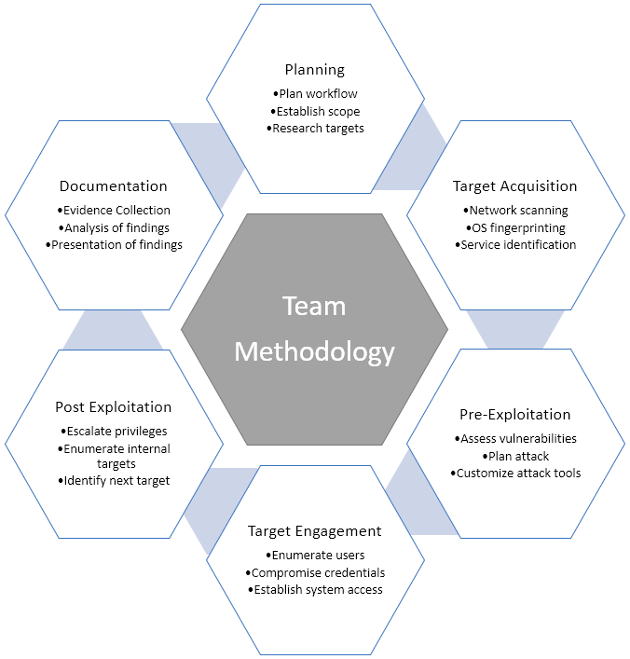

CLASSIFICATION DEFINITIONS

Risk Classifications
Level | Score | Description
Critical | 10 | The vulnerability poses an immediate threat to the organization. Successful exploitation may permanently affect the organization. Remediation should be immediately performed.
High | 7-9 | The vulnerability poses an urgent threat to the organization, and remediation should be prioritized.
Medium | 4-6 | Successful exploitation is possible and may result in notable disruption of business functionality. This vulnerability should be remediated when feasible.
Low | 1-3 | The vulnerability poses a negligible/minimal threat to the organization. The presence of this vulnerability should be noted and remediated if possible.
Informational | 0 | These findings have no clear threat to the organization, but may cause business processes to function differently than desired or reveal sensitive information about the company.

Exploitation Likelihood Classifications
Likelihood | Description
Likely | Exploitation methods are well-known and can be performed using publicly available tools. Low-skilled attackers and automated tools could successfully exploit the vulnerability with minimal difficulty.
Possible | Exploitation methods are well-known, may be performed using public tools, but require configuration. Understanding of the underlying system is required for successful exploitation.
Unlikely | Exploitation requires deep understanding of the underlying systems or advanced technical skills. Precise conditions may be required for successful exploitation.

Business Impact Classifications
Impact | Description
Major | Successful exploitation may result in large disruptions of critical business functions across the organization and significant financial damage.
Moderate | Successful exploitation may cause significant disruptions to non-critical business functions.
Minor | Successful exploitation may affect few users, without causing much disruption to routine business functions.

Remediation Difficulty Classifications
Difficulty | Description
Hard | Remediation may require extensive reconfiguration of underlying systems that is time consuming. Remediation may require disruption of normal business functions.
Moderate | Remediation may require minor reconfigurations or additions that may be time-intensive or expensive.
Easy | Remediation can be accomplished in a short amount of time, with little difficulty.

ASSESSMENT FINDINGS
Number | Finding | Risk Score | Risk | Page
1 | Example Vulnerability Finding | 9 | High | 11
2 | Firewall Rule Set Not Best Practice | 8 | High | 12
3 | Outdated Software | 6 | Medium | 69
4 | Multiple XYZ Vulnerabilities | 5 | Medium | 420
5 | Fake Finding | 2 | Low | 6969
TEMPLATE NOTE: (Sorting by descending risk score)

1 - Example Vulnerability Finding
HIGH RISK (8/10)
Exploitation Likelihood | Possible
Business Impact | Severe
Remediation Difficulty | Easy

Security Implications
This is where you give a 1-2 sentence description about the major impact of the finding. This finding is very important because it can destroy the entire business if left unchecked.

Analysis
Longer discussion of the finding. Includes screenshots. Lorem ipsum dolor sit amet, consectetur adipiscing elit, sed do eiusmod tempor incididunt ut labore et dolore magna aliqua. Ut enim ad minim veniam, quis nostrud exercitation ullamco laboris nisi ut aliquip ex ea commodo consequat. Duis aute irure dolor in reprehenderit in voluptate velit esse cillum dolore eu fugiat nulla pariatur. Excepteur sint occaecat cupidatat non proident, sunt in culpa qui officia deserunt mollit anim id est laborum (see Appendix 1).

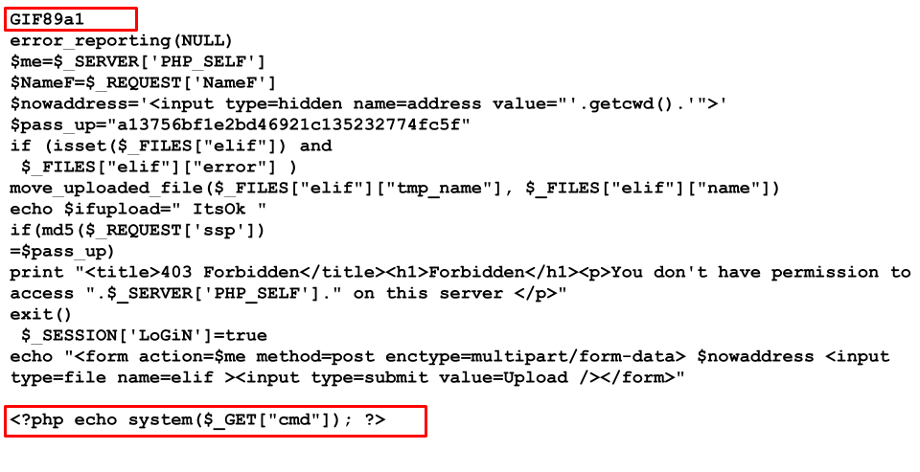
Figure 2.3.1: A php webshell uploaded to XYZ Application

Recommendations
- Remove XYZ to make things more secure
- If you can not remove XYZ do this…

References (opt)
- https://github.com/Sevaarcen/RADAR/tree/master/radar/playbooks
- https://owasp.org/www-project-top-ten/

APPENDIX A - TOOLS USED

TOOL | DESCRIPTION
BurpSuite Community Edition | Used for testing of web applications.
Metasploit | Used for exploitation of vulnerable services and vulnerability scanning.
Nmap | Used for scanning ports on hosts.
OpenVAS | Used to scan the networks for vulnerabilities.
PostgreSQL Client Tools | Used to connect to the PostgreSQL server.
Table A.1: Tools used during assessment

APPENDIX B - ENGAGEMENT INFORMATION

Client Information
Client | <CLIENT NAME>
Primary Contact | <Person Name>,  <Person’s Title>
Approvers | The following people are authorized to change the scope of engagement and modify the terms of the engagement  - <PERSON NAME 1>  - <PERSON NAME 2>

Version Information
Version | Date | Description
1.0 | <DATE HERE> | Initial report to client

Contact Information
Name | <TEAM NAME> Consulting
Address | 1001 Fake Street, Gotham, NY 11201
Phone | 555-185-1782
Email | <REPLACE WITH PROVIDED EMAIL>

